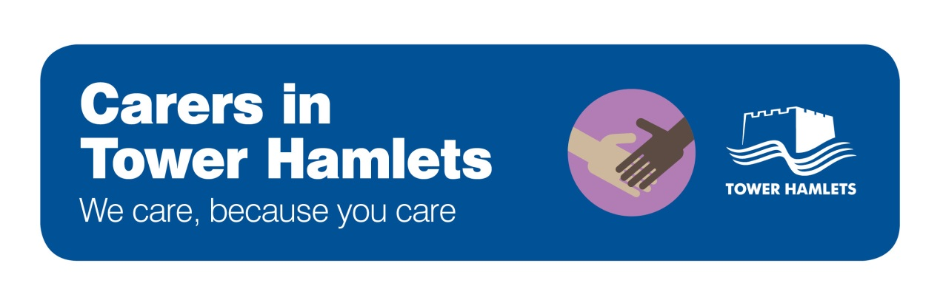

Data protection and confidentiality

What are the basic guidelines for data protection and confidentiality?

- Listen to carers. There can be no breach of confidentiality in meeting a carer and listening to what they have to say
- Usually, you will generally need to gain consent from the cared-for person before sharing information about them with a carer.
- There may be some situations where there are public or personal safety concerns which make information sharing without consent necessary. For example, if the sharing of the personal information is to prevent serious harm to the person or others.
- Staff should assess the person’s capacity to give or withhold consent to the sharing of information. Anything done for or on behalf of a person who lacks mental capacity must be done in their best interests. There is a detailed set of guidance and requirements for staff in relation to this, arising from the 2005 Mental Health Act.

All health and social care professionals are bound by law and professional codes of conduct to this duty of confidentiality to their patients and service users. Please contact the organisation you work for to find out about the resources available to you in relation to data protection (e.g. staff training).

How can I make things easier for carers within these guidelines?

- Discuss information sharing with the cared-for person. Do this at an early stage. Ask if there is any particular information they wish to withhold. Support them to understand the benefits of sharing appropriate information with their carer.
- Encourage the use of advanced directives. This allows the cared-for person to plan their care when they are well in anticipation of when they may be unwell.
- Explain the basics around confidentiality and data protection to carers. Explain to carers what information can be shared and why some information cannot be shared.
- Share general information with carers that is not personal or sensitive and does not breach confidentiality: for example, information about the person’s health condition, the behaviour that may result and how to manage this. A checklist on the factual information you can share with carers can be found here.
- Record issues regarding confidentiality in the cared-for persons notes, so that staff can clearly see this. Carers and the people they care for can find it frustrating to repeatedly give consent for the same information to be shared.
“Mary lives amicably with her sister Carol. For the last two weeks, Mary has become increasingly manic with heightened activity and agitated conversations lasting well into the night. Carol ﬁnally persuades Mary that she needs professional help. By now they are both stressed, exhausted and angry. Mary tells the doctor she wants no further contact with her sister and doesn’t want her involved in any discussions about her care. Fortunately, there was a note in Mary’s records stating that, when she was well, she had given permission for information and decisions to be shared with her sister if she became ill again” – Case study taken from Royal College of Psychiatrists site.

Why is it important to share information with carers?

- Sharing relevant information in a timely manner can have an impact on the wellbeing of both the carer and the cared for person. Without this, the carer may feel unable to continue giving the practical and emotional support that is so important to the patient
- Agreement at an early date over information sharing can prevent problems from occurring later on. For example, carers may feel more equipped to respond appropriately if a difficult situation arises

More information

    - The Royal College of Psychiatrists have useful information on carers and confidentiality. Whilst this is written from a mental health perspective, it is equally applicable to people in other circumstances.
    - The General Medication Council has a good practice guide on confidentiality and patient information.
    - The NHS has a Confidentiality Code of Practice, published in 2003
    - The British Medication Association Guidelines on Vulnerable Adults and Confidentiality provides guidance where adults retain capacity but health professionals believe that they are not making a free or informed choice.
    - The British Association of Social Workers Code of Ethics includes information on confidentiality and sharing information appropriately
    - The Rethink Mental Illness and Mind websites have useful information about confidentiality and mental health.
    - The Caldicott Principles set out a set of principles that health and social care organisations need to follow to ensure that information that can identify a patient is protected and only used when it is appropriate to do so.

