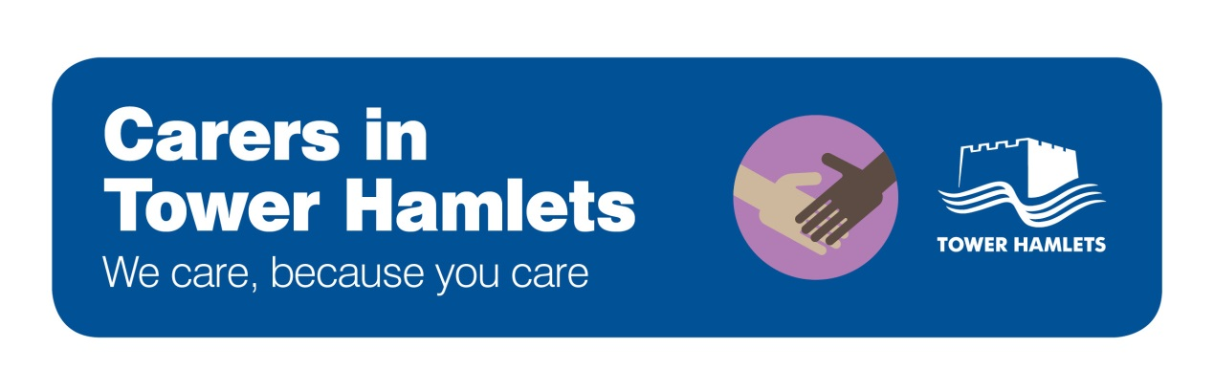

Facts and Figures 2018

How many carers are there in Tower Hamlets?
- There are an estimated 19,356 carers in Tower Hamlets, based on the 2011 Census
- Approximately 5,000 residents are in receipt of Carer Allowance
- We have 406 young carers on our Young Carer Register

How many carers get support?
- Our records show that 378 adult carers received a Carer Needs Assessment in Tower Hamlets last year, though the true figure may be higher
- 297 people received respite care funded by the Council last year, enabling carers to have a break

What do carers do?
- 87% of carers provide practical help to the person they care for, and 74% provide emotional support. 78% help their loved one with care services and benefits, 75% help with medication and 72% help with personal care.
- 25% of carers care for more than 50 hours per week according to the 2011 Census, which is higher than London and England averages

What problems can carers experience?
- 86% of carers say that caring has affected their health or wellbeing, particularly when it comes to feeling tired, disturbed sleep and general stress
- 70% carers report having good health, which is lower than the borough average
- 58% of carers say that caring has caused financial difficulties
- 46% of carers say they are not in work due to caring
- 33% of carers rate their quality of life as good. Most carers say they do not do enough of the things they value or enjoy (76%), do not have enough encouragement or support (68%), do not have enough social contact with others (65%) and are not looking after themselves well enough (56%)
- 26% of young carers said they have been bullied at school because of their caring role in a national survey
- 1 in 20 miss school because of their caring role

5,118 Tower Hamlets residents based on 2016-17 Quarter 3 data. Eligibility criteria involves caring for 35+ hours pw
Young Carer Register as of January 2018
Number of carer assessments carried out in 2016-17.
2016-17 figures
2016-17 Carer Survey report
2011 Census. London: 22%. England: 23%
2016-17 Carer Survey report
In the 2011 Census, 83% of residents report having good health. This dropped to 70% for carers.
2016-17 Carer Survey report
2016-17 Carer Survey report
2016-17 Carer Survey report
Carers Trust UK (https://carers.org/about-us/about-young-carers)
Carers Trust UK (https://carers.org/about-us/about-young-carers)

