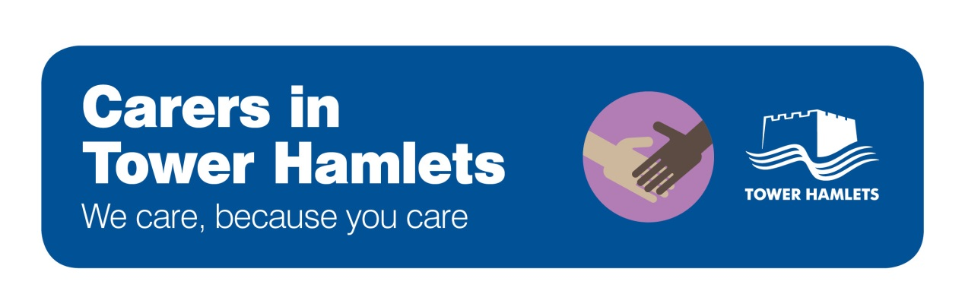

Carers and the 2014 Children and Families Act

Introduction

The 2014 Children and Families Act significantly strengthens the rights of young carers. The main points of the Act as it applies to young carers is set out below:

Young Carer Needs Assessments

- Local authorities must be proactive and take “reasonable steps” to identify young carers in their area who have support needs
- Local authorities must offer to carry out a Young Carer Needs Assessment if they think the child has needs, if the child asks them to, or if the child’s parent asks them to. It doesn’t matter who they care for, what type of care is provided
- The assessment must consider whether it is appropriate for the young person to provide, or continue to provide, care for the person. It must also consider the young carer’s needs for support and their other needs and wishes

Offering Support to Carers

- After the assessment, the local authority must decide what help it should be giving either to the young carer, or to the person being cared for so that the young carer has less demand being placed on them.
- The local authority must consider whether to provide services to support a member of the young carer’s family to reduce the young carer’s caring role.

