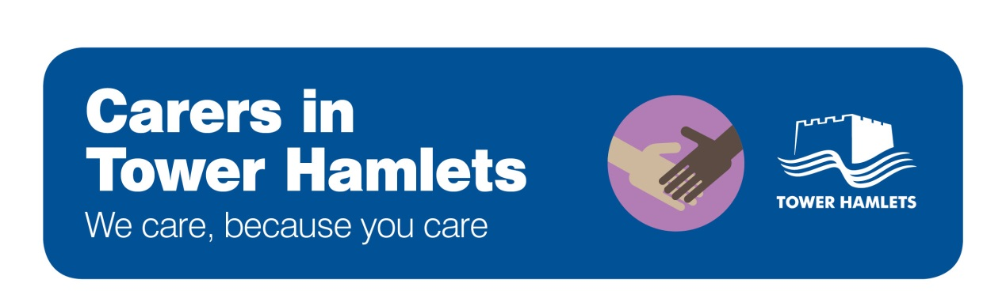

TAKING ACTION IN A CRISIS

- Dial 999 if you need emergency services

- Dial 020 7364 5005 if the issue relates to adult safeguarding, or if an adult urgently needs input from social care

- Dial 020 7364 5601 / 5606 if you are worried about the safety of a child
Dial 020 7364 5555 if you urgently need help from children’s social care

