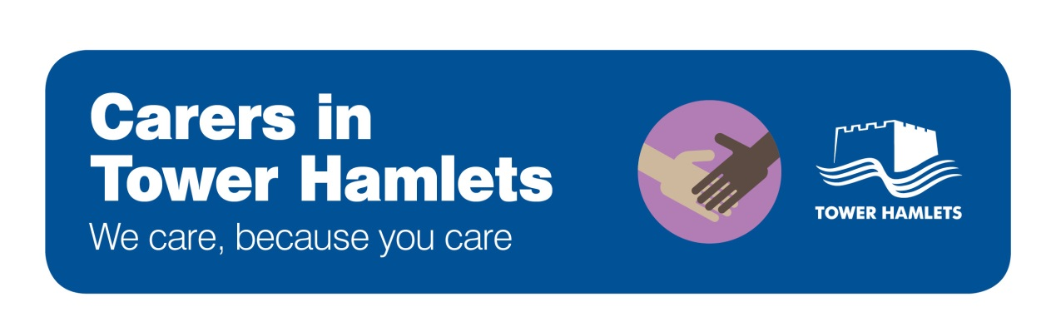

The support options available to carers aged 18 or over
The list below sets out the support services available to carers in Tower Hamlets. These services are free to use. Carers may also be able to get other forms of support following a Carer Needs Assessment, and the Carer Centre can advise carers on this.

      - For all carers (Carers Centre)
Financial, legal, social care, health and other advice

      - For carers of those with dementia (Alzheimer’s Society)
      - For carers of those with mental health problems (Rethink)
      - For Somali carers (BWHAFS)

Advocacy and help to speak out

      - For all carers (Carers Centre)
      - For carers of those with mental health problems (Rethink)
      - For Somali carers (BWHAFS)

Relaxation activities

      - Relaxation days (Carers Centre)
      - Breathing Space drop-in sessions (London Buddhist Centre)
      - Retreats (London Buddhist Centre)
      - For carers of those with mental health problems (Rethink)
Emotional support and support groups

      - For all carers (Carers Centre)
      - For carers of those with dementia (Alzheimer’s Society)
      - For carers of those with mental health problems (Rethink)
      - For Somali carers (BWHAFS)
Training

      - For carers of people with mental health problems (Rethink and Recovery College)
      - Online training for all carers

Carers Centre: Alzheimer’s Society Carer Service:
21 Brayford Square, 020 7790 1765 Mile End Hospital, 020 8121 5626

Rethink Mental Illness Carer Service: BWHAFS Carer Service:
62 Roman Road, 020 8981 2645 82 Russia Lane, 020 8980 3503

London Buddhist Centre Carer Service: National Carers Direct Helpline:
51 Roman Road, 020 8981 1225 0300 123 1053

The support options available to young carers

The support options available to young carers
The list below sets out the support services available to young carers in Tower Hamlets. These services are free to use.
Workshops, training and help with life skills

      - For 13 to 19 year olds (Renaissance Foundation)
      - For 8 to 18 year olds (Young Carers Project)

Fun weekly activities and day trips

      - For 8 to 18 year olds (Young Carers Project)

Emotional or mental health support
      - Emotional support for 13-19 year olds
(Renaissance Foundation)
      - Mental health support for children and young people
(Child and Adolescent Mental Health Services - CAMHS)

      - Family support where there is an adult with a mental illness is available through CHAMP and Building Bridges
Support sessions for families

      - Family support where there is someone with a drug or alcohol problem is available through Reset

Support in
school

      - Family Action can advise you on whether there is a “Young Carer Champion” at the young carer’s school who can help provide extra support to young carers in school.

National helpline and other resources

      - Carers Direct helpline: 0300 123 1053
      - The Tower Hamlets Local Offer is a directory of services for children and young people in the borough
      - Carers UK has useful information and advice for carers. The Children’s Society has information on young carers.
Renaissance Foundation: Young Carers Project:
62 Old Nichol Street, 020 3287 2069 Limehouse Youth Hub, 020 7364 7395

CAMHS CHAMP
020 7426 2375 07506 714 235

Family Action / Building Bridges Reset
62 Roman Road, 020 7364 3406 Mile End Hospital, 020 8121 5301

