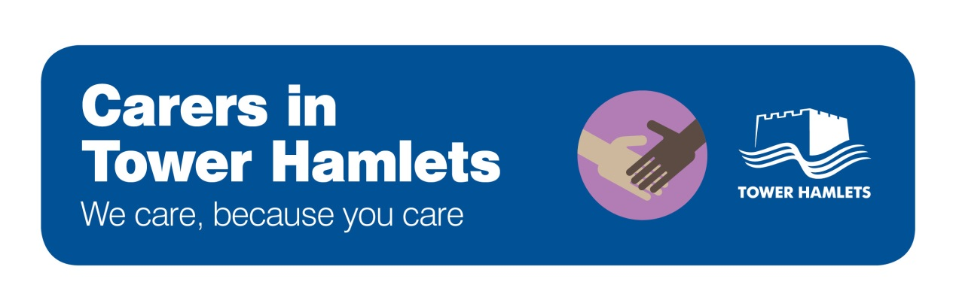

Supporting Young Carers

This step-by-step guide sets out how staff in health, social care, schools and elsewhere can identify and support young carers in Tower Hamlets.

- Identify a young carer
- Listen to and involve young carers in your work
- Refer or offer a Young Carer Assessment
- Support and signpost
- The support options available to young carers
- The support options available to people being cared for
- Taking action in a crisis

- Identify a young carer

- Look out for young carers. A young carer is a person aged 18 or under who help look after a relative with a disability, illness, mental health problem or addiction.

- Be proactive. It is unlikely that someone will tell you they are a young carer, so it is important that you are able to identify them in other ways. The Carers Trust have a list of signs to look out for:

- Being tired or withdrawn
- Anxiety or concern over an ill or disabled relative
- Physical problems such as back pain, as a result of things like lifting an adult
- Behavioural problems. There is often a big difference between the young person who seems “mature beyond their years” in their home environment where they are very protective of a disabled relative, and the young person who takes out their pent-up frustration or stress at school.
- Being late or missing school for no clear reason
- Under-achievement at school, with homework handed in late or not at all
- Being isolated or a victim of bullying – either because of the situation in the family or because they lack social skills when with their peers. In contrast, they may be confident with adults
- Difficulty joining in extra-curricular activities at school

- Understand that some young carers may be worried about getting help. This may lead some young carers to try and hide their role, or be secretive about their home life. Help young carers to realise that getting support can make things better, not worse.

- Look for carers in complex situations. There may be many people caring for one person, with each taking a slightly different role. Alternatively, there may be one or more young carer helping to care for their parents and siblings. It may take time to understand the different roles being played by different people.

- Help people understand they are a young carer. Many people do not know about the term “carer”, or do not see themselves in that way. Some people start giving care at a very young age and don't really realise they're carers. In addition, some people have told us that the term carer feel inaccurate, or condescending to the person being cared-for. Despite this, it may be useful for a young carer to know about the term “carer” so that they can understand what support is available and what to expect from health and social care.

- Understand that young carers have different perceptions of caring. One person might see caring as a stressful activity they never signed up for. Another person might see it as a positive experience they are proud of. Another person still may be ambivalent, and see it as an expected part of their relationship. Carers in all these situations may need support, but their reaction to the offer of support may be different.

- Add the details of the carer to the Young Carer Register. If you are talking to a young carer who does not have a Social Worker and is not getting any support, please email evelyn.williams@towerhamlets.gov.uk with a request to add the young carer’s name to the Young Carer Register (if the young carer agrees to this). Nothing will happen once they are on the register, but it helps us to understand how many young carers there are in the borough.

- Listen to and involve young carers in your work

- Listen and involve. Take the time to listen to young carers views about the person they care for and about their own experiences. Involve young carers in decision-making about the person they care for, when it is appropriate to do so.

- Share information where you can. Carers of all ages often say it can be incredibly frustrating when professionals refuse to share information about the person they care for. Be aware of what is and isn’t possible under confidentiality and data protection for adults and children.

- Refer or offer a Young Carer Assessment for those who may need support

- If it appears that a young carer may be in need of support, or asks for help, you can refer them for a Young Carer Assessment. The Assessment is a social care tool which looks at:
- The caring jobs the young carer does
- How caring affects the young carer
- What the young carer likes or dislikes about caring
As a result of the Young Carer Assessment, the young carer and member of staff should have a view on:
- Whether it is appropriate for the young person to provide care
- Whether the young person needs support

- You can refer the young carer to the Young Carer Project (020 7364 7395 or young.carers@towerhamlets.gov.uk) for a young carer assessment. A member of staff will contact yourself or the young carer as preferred and organise a time to carry out the assessment with them. Other members of staff who are trained to carry out Young Carer Assessments are Social Workers in Children’s Social Care, and staff at the Children and Adult Mental Health Project (CHAMP)

- Understand that carers may have differing reactions to the offer of support or a Young Carer Assessment. Some young carers may need reassurance that the assessment is intended to help them, not make things worse.

- As with any other situation, consider whether the young carer is suffering significant harm through emotional abuse and/or neglect. The “London Child Protection Procedures” has more detail on this in relation to young carers:
“A referral should be made to local authority children’s social care, in line with Referral and Assessment procedures, where a young carer is:
- Unlikely to achieve or maintain a reasonable standard of health or development because of their caring responsibilities;
- Is likely to be suffering significant harm through abuse or neglect;
- Providing intimate body care”

More information on how to make safeguarding referrals to the local authority is available to view here.

- If you are the member of staff who is carrying out the Young Carer Assessment, ensure that your manager has a copy of this for record-keeping purposes.
- Support and signpost

- Explain the support options available to the young carer. Click here to see what these are. There are also other services in the borough that are open to all residents.

- Think about the support the cared-for person is getting. Does the person being cared-for need help from health or social care? Click here to see what some of the services and options are. Also think about the whole family when it comes to support. Are there others who could help, or others who need help?

- Give young carers the information they need about health or social care. A suite of information is currently being developed, depending on the carer’s circumstances. You should also ask the carer if they would like more information on the health condition of the person they are caring for.

- The support options available to young carers
The list below sets out the support services available to young carers in Tower Hamlets. These services are free to use.
Workshops, training and help with life skills

      - For 13 to 19 year olds (Renaissance Foundation)
      - For 8 to 18 year olds (Young Carers Project)

Fun weekly activities and day trips

      - For 8 to 18 year olds (Young Carers Project)

Emotional or mental health support
      - Emotional support for 13-19 year olds
(Renaissance Foundation)
      - Mental health support for children and young people
(Child and Adolescent Mental Health Services - CAMHS)
      - Family support where there is an adult with a mental illness is available through CHAMP and Building Bridges
Support sessions for families

      - Family support where there is someone with a drug or alcohol problem is available through Reset
Support in
school

      - Family Action can advise you on whether there is a “Young Carer Champion” at the young carer’s school who can help provide extra support to young carers in school.
National helpline and other resources

      - Carers Direct helpline: 0300 123 1053
      - The Tower Hamlets Local Offer is a directory of services for children and young people in the borough
      - Carers UK has useful information and advice for carers. The Children’s Society has information on young carers.
Renaissance Foundation: Young Carers Project:
62 Old Nichol Street, 020 3287 2069 Limehouse Youth Hub, 020 7364 7395

CAMHS CHAMP
020 7426 2375 07506 714 235

Family Action / Building Bridges Reset
62 Roman Road, 020 7364 3406 Mile End Hospital, 020 8121 5301

- The support options available to people being cared for
For adults with a physical health problem

      - Local Link can provide information and advice to people with a physical disability on 020 7001 2175
      - If the person needs a social care assessment or reassessment, phone Adult Social Care on 020 7364 5005

For adults with a mental health problem

      - If the person is not getting any help with their mental health issue at the moment, they will need to speak to their GP as a first step
      - If the person is already getting support from mental health services, contact their mental health team. or Building Bridges
For adults with a learning disability or autism

      - The Tower Hamlets Community Learning Disability Service provide health and social care support to adults with a learning disability
      - The Adult Autism Service provides diagnosis and post-diagnostic support for adults with autism

For people with a drug or alcohol problem

- Compass provide help for 10 to 19 year olds with drug or alcohol problems
- Reset provide support and help to adults with drug or alcohol problems

For children or young people with a disability

- The Local Offer lists services and support for children and young people with special educational needs and disabilities. The Parent Advice Centre can be a good place to start on 020 7364 6489.
- If the person needs a social care assessment or reassessment, contact the Children with Disabilities team on 020 7364 2724
For children or young people with a mental health issue

- The Local Offer lists services and support for children and young people with special educational needs and disabilities. The Parent Advice Centre can be a good place to start on 020 7364 6489.
- The Child and Adolescent Mental Health Services (CAMHS) can provide advice and support

- Taking action for young carers in a crisis
- Dial 999 if you need emergency services
- Dial 020 7364 5601 / 5606 if you are worried about the safety of a child
- Dial 020 7364 5555 if you urgently need help from children’s social care
- Dial 020 7364 5005 if the issue relates to an adult being cared for urgently needing input from social care

